Adjunct Faculty details
Department name: Master of Computer Applications
 | Name: | 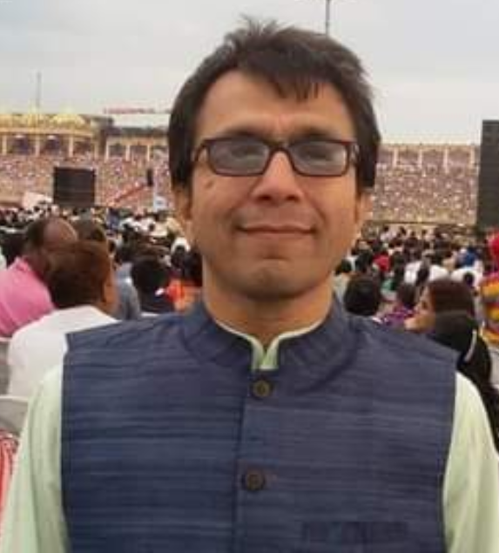  Dr. Manoj Dahal
 | Qualification: | Ph.D.
 | Area of Specialization: | Network Protocols, Machine Learning
 | Organization currently working in: | Ex-Cisco | Ex-Microfocus | ex-INRIA | Ex-Novell
 | Current Designation: | Consultant, Freelance
 | Experience (in years)
 | - in Industry: | 20
 | - in Academia: | 02
 | - In R&D centers: | 02
 | Courses they will be handling in GIT: | Distributed Systems, Security
 | Domain :
 | Brief profile (mentioning current employment status, previous experience in other organizations, any awards/achievements, grants received, paper publications, patents, books published etc not exceeding 100 words): | He is an accomplished and dynamic technologist with multifaceted qualities in the areas of Leadership, Innovation, Software Architecture and Development. I am capable of leading & supervising teams for successful completion of software product development. A quick learner and can pick up a technology within a short span of time. In an organization can contribute immensely with full intensity, passion, foresight and leadership to open up newer dimensions and initiatives.  The Technology Areas of interest include (but not limited to) Distributed Systems, Security, SaaS, Network Protocols, Machine Learning, Cloud and Storage.  Some of the Publications/Presentations  - “US Patent: Malware Management Using I/O Correlation Coefficients”, https://patents.google.com/patent/US20210173930A1/en, June 2021  - “Threat detection on Network Resource Access based on Behavioral Analysis of User Access Patterns and Machine Learning:  A Report”, IM & G Tech Journal (Micro Focus Internal), Volume 1 – April 2021  - Tech Talk: BotNet and Threats to Internet (at Micro Focus), July 2020  - “Detection of Abnormal Conditions in NCP Packets Using Machine Learning Algorithms”, Microfocus IDC Tech Journal, Issue 6, June 2016, India.
 | Email: | dahal_m@yahoo.in
 | Mobile No: | +91-9036429050
 | Address: | Udipalya, Kanakapura Road  Bangalore-560082, India

